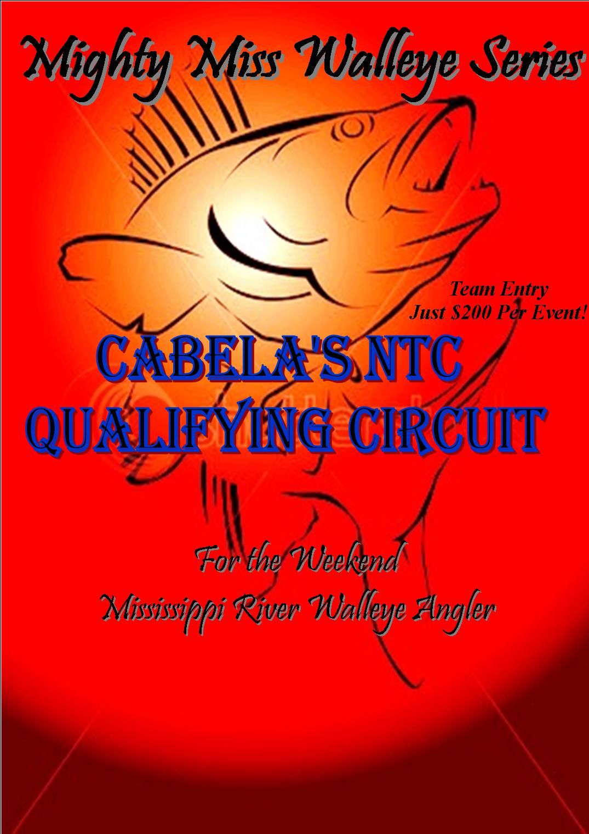
Hosted by: Radcliffe Promotions LLC

2016 MMWS Tournament Schedule:

- April 23rd: La Crosse, WI (Pool 8 & 9) 7th Street Ramp
2.) May 28th: Trempealeau, WI (Pools 6, 7, & 8) Lock Landing
3.) July 16th: Mystery Pool Tournament (19 boat limit)
4.) September 10th: Trempealeau, WI (Pool 6,7, & 8)
*schedule location subject to change dependent upon permit availability*

Tournament Format: Each MMWS Tournament will be a one day format. Anglers can pre-fish up to 5:00 p.m. the day before the event. The qualifying events all will be held on Saturdays.
Pre-Tournament Meeting: A mandatory pre-tournament rules meeting will be held on Saturday morning at 6:45AM prior to the event. One team member must be present from each team at this meeting. The meeting location will be at the event landing. Team registration, boat number designation, rule review, and questions will be taken at that time.
Participation and Eligibility: There will be no age limit; however an adult must accompany each person under the age of 18. Only two (2) persons will be allowed per boat. The tournament director(s) reserve the right to refuse any entrant. Full Field is limited to ONLY 19 teams. If the field fills, alternates will be placed on a waiting list in the order of entry received. SEE FLIGHT OUT ORDER in rules for important details.*
Application and Deadline: Entry fee deadline is Sunday at 5:00 p.m. the weekend prior to the event. LATE Entries will be accepted up to 6:45AM at the pretournament meeting. However, after the Sunday deadline a $50.00 additional late fee will apply to fish the event. *Once the 6:45 AM meeting begins, no additional teams can get in so don’t be late.* A completed application by both team members must be signed and submitted (or have Sunday’s postmark) with payment in full at that time. Refunds will only be given up to the Sunday deadline as well with a $50 penalty to the team(s) not electing to fish. Reminder: 19 boat limit per event. All late fee money collected through the year will be used to further promote the trail as seen fit by the director and staff.
Substitutes: A team may substitute one member but not both to maintain their team points and status. In the event neither team member can compete, the entry fee will not be refunded, but included in the final payout. Please contact the director if an emergency situation does arise.
Sportsmanship: Each team is a representative of MMWS and is expected to follow a high standard of sportsmanship, courtesy, safety, and conservation. Any team failing to uphold this professionalism may be disqualified.
Alcoholic Beverages and Drugs: NO alcoholic beverages or other stimulates or depressants shall be allowed in the tournament boats or in possession of the contestants prior to morning check in or during the tournament hours. Absolutely NO Exceptions!
Liability: The MMWS (Mighty Miss Walleye Series), its officers and employees, promoters, tournament directors, sponsors, volunteers, and organizations assisting in the tournament operation, their agencies, etc are not responsible for deaths, injuries, damage, liability, theft, fire, or any loss of any kind to entrants. Each entrant, upon signing and entry form, will be signing a waiver form.
Disqualification: *Disqualification from the tournament for any reason will result in forfeiture of entry fee.*
Photo Release: We agree any photographs, video, or other promotional material taken during a MMWS event is property of the MMWS and may be used by the MMWS, its sponsors, or the media without royalties or prior consent.
REGULATIONS
Permitted Fishing Locations: MMWS tournaments will be based on Pools 4 - 9 on the Upper Mississippi River. See which pools will be fished per event on the official entry form page (attached). Tributaries can be fished but must be accessible by boat and proper WI, MN, and IA state licenses and regulations must be upheld and followed by both team members. All angling must be done from the boat. Contestants must not depart boat to land a fish. Both anglers must remain in the boat during the tournament day. Contestants must leave and return to the official checkpoint by boat. Both competitors must remain in the boat except in case of emergency or life threatening weather. Trailering of boats during tournament hours is prohibited except for coming to the scales directly from the launch ramp to weigh-in stage.
Tournament Hours: Flight out will begin at 7:00 a.m. and end at 3:00 p.m. Any boat not checked in by 3:00 p.m. is disqualified. It is your responsibility- no exceptions.
Boat Qualifications: All tournament boats must measure a total length of fourteen (14) feet and a minimum of 15hp for safety reason. Each boat is required to possess liability insurance for their boat in any MMWS event- it is the owner’s responsibility to posses this. All boats participating must be in good operating condition and have a functioning recirculating live well system capable of adequately maintaining a tournament weight. We strongly encourage the use of a catch and release agent such as (Rejuvenade) www.bassmedics.com and/or ice to assist in maintaining the best possible condition of the fish.
Life Jackets: Life jackets must be zipped and buckled. Kill switch must be attached to the life jacket of the boat operator anytime the main combustible engine is in operation above idle speed. All life jackets must be US Coast Guard approved.
Tackle and Equipment: All fish must be caught in a legal and sporting manner per the state regulations. Intentional snagging of fish will not be allowed. State certified live bait or artificial lures may be used. It is the contestant’s obligation and responsibility to produce adequate documentation to ensure all state and local bait regulations are followed. Violation or issuing of a citation by a DNR official will result in immediate disqualification.
Invasive Species: Aquatic invasive species can crowd out native plants and animals and threaten the future quality of the waters we fish. Boaters can take action to prevent the spread of these. Inspect and remove aquatic plants, animals, and mud from your boat, trailer, and equipment before leaving the landing. Drain water from live wells and bait containers before leaving the landing. Dispose of unwanted bait in the trash. Pressure wash your boat and equipment at a car wash or at home with hot water, especially if moored for more than a day. Otherwise let your boat dry for a minimum of five days before the next use. Wisconsin laws prohibit launching a boat, boat trailer, or boating equipment if there are any aquatic plants or zebra mussels present. Unfortunately, the Mississippi River has several exotics and we all need to do our part to ensure they do not spread to other bodies of water
RULES:
The following rules will remain unchanged throughout the events unless State or Local Laws are in conflict. Interpretation and enhancement of the rules will be left to the tournament director and ethics committee. In the event of a rule violation, the committee may impose such sanctions, as they deem appropriate, including without limitation to, disqualification, forfeiture of prizes, entry fee and prohibition from participation in subsequent tournaments. The decision of the Tournament Committee shall be final in all matters. It is the committee’s discretion to make changes where safety is concerned. All participants must comply with all Coast Guard, State, and Local Regulations. ANY competitor receiving a citation for violations of any Coast Guard, State, or Local regulations will be disqualified immediately. It is the contestant’s responsibility to know and follow these regulations.
Permitted Fishing Locations: Each event the Director will discuss the permitted pool or pools at the pre-tournament meeting as designated on the registration form. Tributaries can be fished but must be accessible by boat and proper WI, MN, and IA state licenses and regulations must be held and followed by both team members. All angling must be done from the boat. Contestants must not depart boat to land a fish. Both anglers must remain in the boat during the tournament waters during the tournament day. Contestants must leave and return to the official checkpoint by boat. Both competitors must remain in the boat except in case of emergency or life threatening weather. Trailering of boats during tournament hours is prohibited except for coming to the scales for weigh-in at the launch landing. Only in the event of a boat breakdown or malfunction can a team member board another competing team’s boat. One member of the team may bring his catch to the scales with another team, but his catch must be separated into a separate live well or section of the live well to insure fish are segregated or tagged. Only a competing team can bring in another team. Any other non-tournament or non-director authorized boat will disqualify the team’s catch. The captain of the disabled boat must stay with the vessel until a proper rescue boat can tow them in to the nearest safe harbor or landing. This is the responsibility of the owner of the boat. The director must be notified immediately if this situation occurs.
Protest and Grievances: Sportsman like conduct and boating safety is highly enforced. Any protest grievance by any individual(s) must be brought before the director prior to the end of weigh-in. A $75.00 cash fee must be filed with the grievance and the person filing it must put it in writing. If the grievance on the other team or individual is found to be unquestionably true the fee will be reimbursed to the individual. An ethics committee appointed along with the director(s) will meet in this instance to decide the fate of the grievance. If the team is found to have violated the tournament rules, penalties up to, and including disqualification will be enforced. If the violation is found to be without merit the $75.00 protest fee will go towards promoting future events.
Pre-Tournament Inspection: All boats are required to use the prescribed landing the morning of the event for put in. A trailered inspection of the boat’s livewell prior to the event is mandatory by a designated tournament official. Failure to have this done will result in disqualification. Orderly launching of the boats is expected. Please respect other local recreational anglers and allow them priority access to the ramp as they may arrive during the launch process. Please be respectful and give room as this is their landing as well.
Flight Out Order: Flight out number for morning take off will be determined by date of paid entry fee.
Main Dam Lockage: THIS IS NOT A RACE. First boat in is first boat out. Period! Failure to follow this will result in Automatic Disqualification. Safe locking rules must be followed by all teams. Please be considerate and respect your fellow teams and take into account differences in boat sizes and abilities. Lockmasters are contacted at each event and are will notify the director of misconduct.
Weigh-in procedure: Tournament scales will open at 2:00 p.m. Once your team weighs in, you are DONE fishing for the day. A drive through weigh-in format will be used at all events. We ask you fill your livewell FULL and have water recirculate on the fish prior to, during, and after the fish are weighed. It is each team’s responsibility to take care of their fish after they are weighed at the scale. Bags or baskets are available upon request at the scale. We insist that patience and courteous conduct be used during the weigh-in procedure, please form a line, or check in even if not weighing any fish so your team is accounted for.
Scoring: Placing will be set upon total weight of FOUR (4) 15” > fish weighed. Walleye, Sauger, and Saugeye only can be weighed with a minimum state law length of 15”. Six fish may be in possession per team when arriving at the scales. The team must choose their best four to be weighed. Any short fish not measuring the 15” size limit will result in disqualification. Fish will be measured with the mouth closed and the tail pinched. “The Judge” is the official measuring board of the MMWS Trail. A courtesy “Judge” bump board will be provided if needed. The weigh master’s discretion is final on all measured length and dead fish. Large fish in contention for big fish pot will be inspected closely and are recommend to be weighed in live to ensure their safe release. Weight cheating (i.e. adding sinkers) or excessively obvious long term dead or caged fish are grounds for immediate disqualification from current and all future events.
Ties: Ties between places will be determined by the team’s largest fish recorded at the time of weigh-in, then by flip of the coin.
BIG WALLEYE POT: Your selection of the (one) largest fish will be given to go for the 100% payout ($20 per team) BIG FISH POT. Each team is highly encouraged to weigh their largest fish. In the event of a weight tie, the pot will be split equally between the top big fish teams.
The MMWS Executive Director’s ruling is the final decision to all rules interpretations. ALL decisions are FINAL.

ENTRY FEE and BIG FISH SIDE POT
Entry Fee: Each two man team is required to pay a $180 entry fee plus $20 Big Fish Pot ($200/ event). A percentage of the proceeds will go to cover tournament administration fees, permits, insurance, prizes, and future promotion of the trail. Payouts and number of places will be determined based upon the number of boats competing in each event. Payout schedule will be announced at the pre-tournament meeting Saturday morning. All winnings are subject to tax per federal laws in excess of $600 per angler ($1,200 per team).
Points System: Points accrued through the season determines who is MMWS Team of the Year. Overall total points determines placement to the 2017 Cabelas NTC Championship from the four qualifying events.
Mystery Event: All teams will meet Friday night at the “Sunfish” Park on Hwy 35 in Onalaska across the road from the Blue Moon Bar and Restaurant. The Mystery Pool (5A, 6, 8, or 9) will be selected at random from a drawing and the next morning we will fish that pool. Pools 4, 5, & 7 have already been fished in previous years and thus are NOT a draw option this year. Due to permit limitations only the first 19 boats paid and registered can fish this event so do not delay getting into this event.
MMWS Series Championship: There will not be a series Championship for 2016; just four standard events. However, the team with the most points from the four events will receive Season Champs trophies at the end of the September event just as had been done at past Championships.
BIG WALLEYE POT: From each entry fee $20 goes towards the Big Fish Pot which is 100% payback. Only one place will be paid out to the largest individual walleye weighed.
News & Updates: Please be certain to put your current e-mail address and cell phone number on your entry form. All press releases, rule alterations, location and date changes will be sent to you direct so it is critical you have a working e-mail address and contact phone number. Other updates will also be posted on www.walleyefirst.com on the Walleye Tournament Forum if for some reason you do not have e-mail. This will be the official website for information. Also visit our Facebook site under Mighty Miss Walleye Series for all updates and photos and become a friend. If you should need to contact us please do so via e-mail at MMWSdirector@live.com or call 608-498-9900 evenings.
Let’s Fish!

~ 2016 Mighty Miss Walleye Series – Official Entry Form ~
Entry Fee - $200 per event – $20 Big Fish Pot Included
Check Line(s) for Tournaments You Wish To Enter: All Dates are Tentative Upon Permitting
Please enter us as a team: _____$800/ Season (One time payment includes Big Fish Pots)
Cabelas NTC -Walleye Federation Membership Dues: ______$80/ Team Season (one-time payment)

1.( ) LaCrosse, WI (Pool 8&9) 2.( ) Trempealeau, WI (Pools 6,7,&8)
April 23th, 2016 May 28th, 2016
Saturday 7-3 Saturday 7-3
7th Street Ramp Lock & Dam Ramp

3. ( ) Mystery Event 4.( ) Trempealeau, WI (Pool 6,7,&8)
July 16th, 2016 September 10th, 2016
Meeting at Sunfish Park Friday 6PM Lock & Dam Ramp

REMEMBER: 50 BOAT LIMITED FIELD – Please Print Info Below!
*Name_________________________________ *Name_____________________________________
*Address_______________________________ *Address___________________________________
*City__________________________________ *City______________________________________
*State________________*Zip_______________ *State___________________*Zip_______________
DOB___/____/19____ DOB___/____/19____
*Social Security #_______-_____-__________ *Social Security #_______-_____-__________
*Daytime Phone/Cell (______)______-_________ *Daytime Phone/Cell (______)______-_________
*E-Mail Address_____________________________ *E-Mail Address____________________________
Note ALL areas marked with an ( * ) must be completely LEGIBLY filled out or you risk your boat position, and will be released as last boat during flight out. (BOTH SHEETS)

~ Mighty Miss Walleye Series Release of Liability: ~
Radcliffe Promotions L.L.C

Please Read Carefully Before Signing!

I acknowledge that I am voluntarily participating in the tournament(s).

I am aware that my participation in the tournament(s) listed on my entry form creates the risk of my serious personal injury or death. My participation could also lead to loss or damage to my personal property. I expressly agree to assume all risk of injury and/ up to death and loss of personal property which may result from my participation in these Fishing Tournaments. In exchange for being permitted to participate in the tournament(s), I hereby RELEASE AND DISCHARGE the tournament’s organizer and the tournament sponsor’s, their officers, directors, agents, employees and legal representatives (the “Released Parties”) from any and all liability for any injury, damage or any loss sustained by me which may arise from my participation in the above tournament, including , but not limited to, any claim I or my heirs may have for loss, personal injury or casualty of any kind, injuries, damages or other loss sustained by me, caused by the negligence or strict liability of the Released Parties. I do not release the Released Parties from liability for willful or intentional misconduct. I expressly recognize that loss of property, injury, or death could arise from (1) the fishing and boating activities contemplated by the tournament. (2) the fact that competition rules contemplate that some participants will fish in boats belonging to OTHER participants in the contest. (3) the fact that the risk normally encountered in open water fishing from a boat may be enhanced by the exposure to the elements and other risks inherent in an outdoors competition. I warrant that I am in good physical and mental health and am physically capable of withstanding the rigors and requirements of a professional level fishing competition
I have read the release of liability and participant agreement carefully and understand all of its terms and conditions. I sign up voluntarily and without reservations. This waiver is a legal binding contract, I recognize this. This waiver replaces any previous release.

*Signature – Team Member One: ________________________________________________
*Today’s Date: ____________________________________

*Signature – Team Member Two: ________________________________________________
*Today’s Date: ____________________________________

Both Team Members Must Sign and Date!
*Make Checks Payable to: Radcliffe Promotions L.L.C.*
Mail To:
Mighty Miss Walleye Series
c/o Dale Radcliffe- Executive Director
1040 Brickl Road
West Salem, WI 54669

