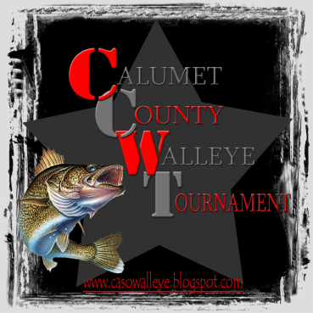
11th Annual Calumet County Law Enforcement Walleye Tournament
(www.casowalleye.blogspot.com)
June 11th, 2013
6:30am – 2:00pm
LAKE WINNEBAGO ONLY
FROM STOCKBRIDGE HARBOR
$60.00 TEAM ENTRY FEE (includes big fish) NO REFUNDS AFTER JUNE 06
100% PAYOUT
(BAD WEATHER DATE IS JUNE 25th, 2013)

ENTRIES MUST BE POSTMARKED ON OR BEFORE JUNE 3RD, 2013
NO EXCEPTIONS!

- Open to anyone in Law Enforcement, Corrections, Probation & Parole (active or retired), and Calumet County employees.
- One person enrolling must meet above requirements *Must enter as two person team
- This tournament will be a catch and keep tournament (walleye only)
- Teams will be allowed to weigh (5) fish * The minimum length of eligible fish is 15 inches
- All state rules regarding fishing/boating will be observed
- Lightest basket of fish will receive a gift bag
- All prizes will be awarded by total weight
- Prizes will be awarded at the conclusion of the tournament at the Harbor Bar (located next to the boat landing)
- Big fish pays three places; you may only weigh one fish per team.
- Check in time 5:00am to 6:00am *Flare gun start * Live wells will be checked
EXAMPLE OF PAYOUT BASED ON 50 BOATS
1ST $700.00 6TH $95.00 11TH $70.00
2ND $475.00 7TH $90.00 12TH $65.00
3RD $300.00 8TH $85.00 13TH $60.00
4TH $200.00 9TH $80.00 14TH $55.00
5TH $100.00 10TH $75.00 15TH $50.00

CONTACTS: Dan Van Oss Todd Konen Scott Schwarz
920.810.3323 920.843.5056 920.312.0119
920.849.1447 920.849.1447 920.849.2335
Make checks payable and mail to: Dan Van Oss
1005 Red Oak Lane
Appleton, WI 54915

Please indicate what Agency you work for_______________________________________

PARTNER 1_______________________ PHONE NUMBER_____________________

EMAIL ___________________________

PARTNER 2_______________________ PHONE NUMBER_____________________

EMAIL ___________________________

