Help prevent the spread of the VHS virus and other exotic species.

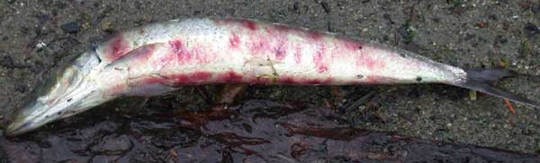

New requirements for anglers and boaters to keep fish healthy
Emergency rules effective April 2007 require that boaters and anglers:
Drain all water from your boat, trailer, bait buckets, coolers, and other containers before you leave the landing or shore fishing site location on Lake Michigan, Lake Superior, the Mississippi River or their tributaries).
Do not transport live fish, including bait fish, away from any Great Lakes or Mississippi River drainage landing or shore fishing location. This includes tributaries up to the first dam.
Do not use "cut" or dead bait from other waters (except when fishing in Lake Michigan, Green Bay, or tributaries).
Do not use minnows unless they were purchased from a Wisconsin bait dealer or you legally caught the minnows from the place you are fishing.
Draining all water from boats and boating and fishing equipment is strongly recommended after boating or fishing on all Wisconsin waters, as is inspecting your boat and trailer and removing all visible plants and animals. These steps will also help prevent the spread of other diseases and invasive species.
Additional steps to prevent the spread of invasive species:

If you fish the Winnebago system please disinfect your boat and gear before moving to new waters by mixing one cup of bleach with 10 gallons of water. Apply the solution to the hull, trailer, live well, bilge and any other areas or things that may hold water or moisture. Leave the solution on for at least five minutes before rinsing and don't rinse the bleach solution into lakes or rivers. You can also dry out your boat and equipment for (at least) five days.

- Do not move live fish or fish eggs, including unused bait minnows, away from the landing or shore. Dispose of leftover bait in the trash, not in the water.

- Drain all water from bilges; bait buckets, live wells and other containers when leaving the landing or shore.

- Use live minnows purchased only from registered bait dealers in Wisconsin, or catch it yourself in the same water you fish. But please do not transport these to other waters.

- Before launching and before leaving for the day, inspect your boat and trailer and clean both of all visible plants and animals.

- Report large numbers of dead fish or fish with bloody spots to your local DNR fish biologist or conservation warden.

- Kill your fish after fishing Winnebago, the Great Lakes or Mississippi River.

For More Information please visit these web sites:

http://www.protectyourwaters.org/

http://invasivespecies.wi.gov/awareness/index.asp

http://www.iwla.org/index.php?id=461

http://www.seagrant.umn.edu/newsletter/2007/02/law_center_identifie...

http://www.great-lakes.net/envt/flora-fauna/invasive/invasive.html
http://www.uscg.mil/hq/g-m/mso/ans.htm
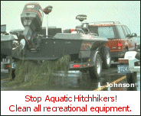
http://www.great-lakes.net/teach/pollution/ans/ans_1.html
http://www.nmc.edu/glwsi/
http://www.glerl.noaa.gov/res/Programs/nsmain.html
http://www.glc.org/ans/pdf/briefpapercomplete.pdf

http://www.postcrescent.com/apps/pbcs.dll/article?AID=/20070513/APC...

http://blog.midwestlakes.org/06-11/viral-hemorrhagic-septicemia.htm...

http://www.glu.org/english/invasive_species/saltfreelakes/index.htm

