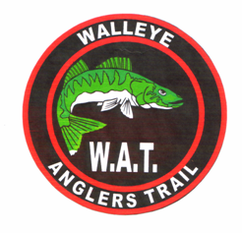
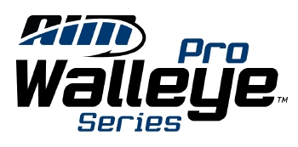

The Walleye Angler’s Trail has been invited to send a qualifying team to participate in the Angler’s Insight Marketing (AIM) International Walleye Championship scheduled for September 2 – 4, 2009 located on Lake Winnibigoshish in northern Minnesota.

All Pro Angler participants will have the opportunity to compete for the total payout of not less than $150,000.00 - based on a minimum 100 boat field. The payout will exceed $150,000.00 significantly based on the potential for 150 boats or more!

First place will win a prize package valued at over $65,000.00, including a minimum of $10,000.00 in cash and a Lund 2075 Pro V Boat and Mercury Verado motor package!

* Each member of a qualifying “Team” may choose to enter as a Pro Angler ($1500 entry) or Co-angler ($250 entry.) Cash prizes apply ONLY to Pro Angler entries. The Pro Angler provides the boat, all the fishing tackle and bait for the day. Each day the Co-angler will be paired with a different Pro Angler. AIM has waived the membership fees for this tournament. Other tournament rules can be found at the AIM™ website: www.aimfishing.com

To qualify, WAT teams MUST fish the first three WAT Tournaments and the team that is in first place (Team points) after the third tournament (Albany, IL - May 31, 2009) will be given the opportunity to participate in the AIM International Walleye Championship. If for any reason the qualifying team declines the invitation it will go to the next highest scoring team.

